**Project Design Phase-II**

**Data Flow Diagram & User Stories**

|  |  |
| --- | --- |
| Date | 10 March 2025 |
| Team ID | SWTID1741258148149965 |
| Project Name | Cryptoverse: A Cryptocurrency Dashboard |
| Maximum Marks | 4 Marks |

**Data Flow Diagrams:**

The given **flowchart** represents the navigation and data flow of **Cryptoverse: A Cryptocurrency Dashboard**, illustrating how users interact with the platform to access cryptocurrency data. The process begins at the **Start** point, where the user lands on the **Home Page**. From here, the system fetches real-time cryptocurrency data using a **Coin Ranking API**, ensuring that users receive the latest market information.

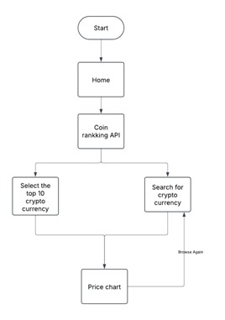

**User Stories**

Use the below template to list all the user stories for the product.

|  |  |  |  |  |  |  |  |
| --- | --- | --- | --- | --- | --- | --- | --- |
| |  | | --- | | **ID** | | |  | | --- | | **User Role** | | |  | | --- | | **Feature** | | |  | | --- | | **Description** | |
| |  | | --- | | US-01 | | |  | | --- | | User | | |  | | --- | | Navigate to Home Page | | As a user, I want to access the home page so that I can start using the cryptocurrency dashboard. |
| |  | | --- | | US-02 | | |  | | --- | | System | | |  | | --- | | Fetch Data from Coin Ranking API | | As a system, I need to retrieve real-time cryptocurrency data from the Coin Ranking API so that users get the latest information. |
| |  | | --- | | US-03 | | |  | | --- | | User | | |  | | --- | | View Top 10 Cryptocurrencies | | As a user, I want to see a list of the top 10 cryptocurrencies so that I can quickly access trending coins. |